Strahan Clarke exhibition talk
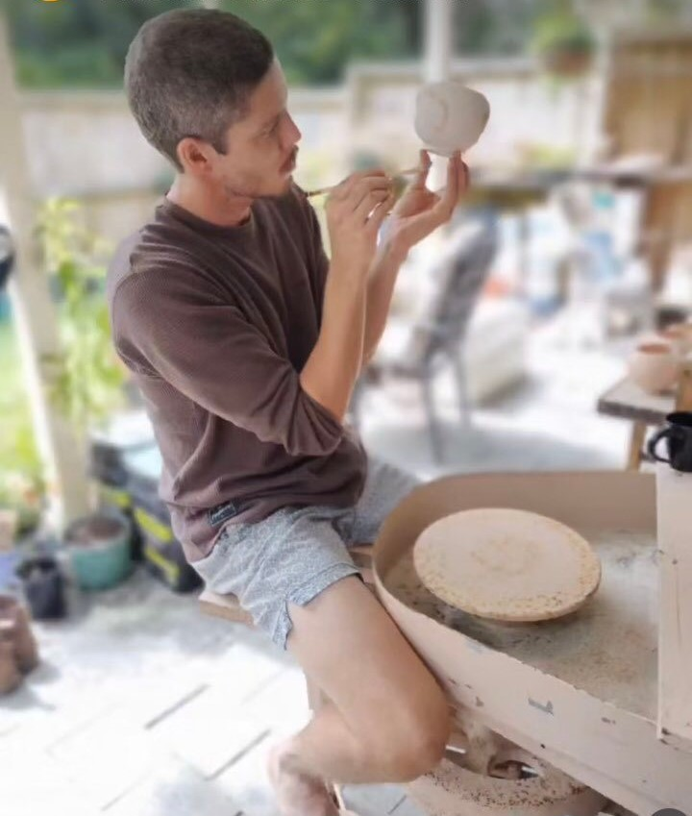 |  | Kia ora friends,  Please join us at Hangar Gallery to hear artist Strahan Clarke talk about his current exhibition Symbols and Sentiment and his extensive art practice.  Refreshments will be served. We look forward to seeing you this weekend. Best wishes Megan and Baz
Saturday 25th March 10am
14 Cross St Regent Whangarei

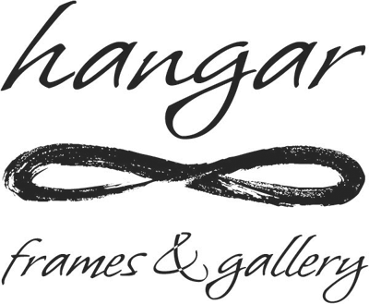 |  | 09 4381260 | frameskamo@xtra.co.nz | www.hangarart,nz

